

Technical data

PROSECCO
EXTRA DRY

Variety |  | Glera for Prosecco production
Production zone |  | Friuli Venezia Giulia
Denomination |  | Protected Designation of Origin (PDO)
Type of soil |  | Sandy-Skeletal Soil
Farming system |  | Double inverted System and complementary
Plants per Hectare |  | About 3000 - 3500
Harvest period |  | September
Fermentation |  | In White, in steel tank, 14°C
Sparkling process |  | Charmat Method
Refining |  | In bottle
Alcohol content |  | 11.50 % vol.
Residual sugar |  | 13 g/l
pH |  | 3.20 -3.30
Overpressure |  | 5.5 bar
Packaging |  | Boxes with 6 bottles
Serving temperature |  | 6 – 8 °C
Stopper |  | Cork
Colour |  | Straw yellow
Flavour |  | Aromatic, fruity and floral
Taste |  | Smooth, ample, dry with fine, persistant perlage
Accompaniment |  | Ideal as aperitif  Contains Sulphites  Consumption by minors prohibited

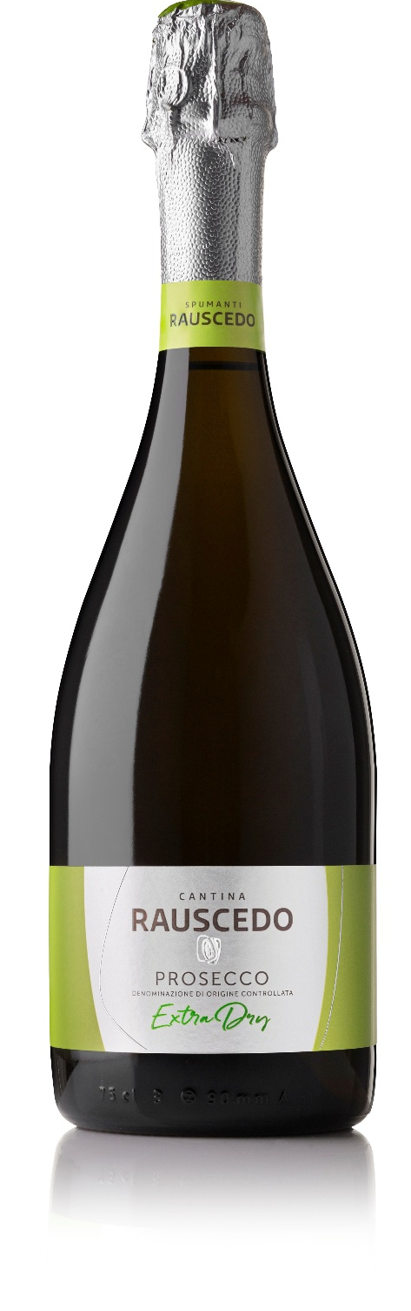

CANTINA RAUSCEDO - Via del Sile, 16 - 33095 Rauscedo (PN) - P. Iva 00072770936 - www.cantinarauscedo.com

